Supporting Information for
Capillarity-driven hydrate film formation in geologic carbon storage.

David E. Fukuyamaª, Hugh C. Daigleª, Wen Song^{*a}

*Wen Song.

Email: wensong@utexas.edu

This PDF file includes:

Supporting text
Figures S1 to S2
Legends for Movies S1 to S2

Other supporting materials for this manuscript include the following:

Movies S1 to S2

Side view of etched micromodel
A cross-section of the etched micromodel is shown in Fig. S1. The scanning electron micrograph shows a smooth bottom surface enabled by anisotropic etching. Grain walls, however, are rough and capable of retaining bulk bodies of water. Smooth surfaces are representative of silica grain surfaces in ocean floor sediments, while rough wall surfaces mimic those of clayey materials.

Schematic of microvisualization setup for hydrate formation
A schematic of the experimental setup is displayed in Fig. S2. Two Quizix QX Series 6000 pumps control the gas and water pressure on the upstream and downstream end of the micromodel. The micromodel is cooled in a cold water reservoir with fluid cooled and circulated by a Fischer Thermal IsoTemp.

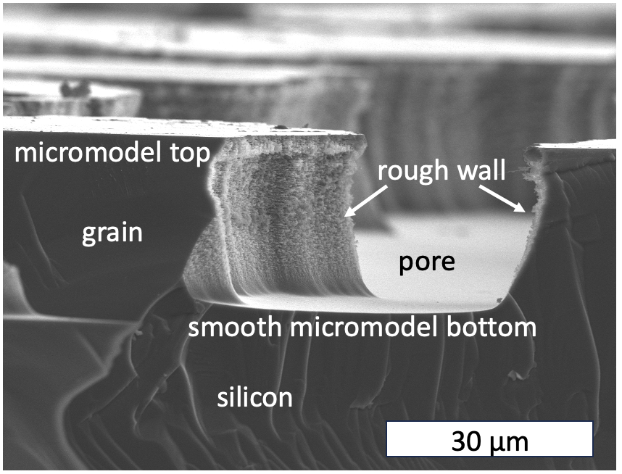
Fig. S1. Side view of an etched micromodel showing smooth bottom surfaces and rough grain walls.

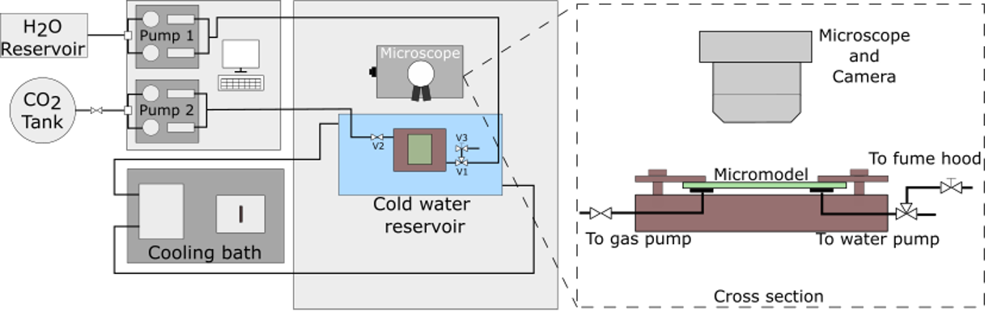
Fig. S2. Hydrate formation in micromodels. Two Quizix pumps were used to regulate pressure on the upstream and downstream ends of the micromodel. A Fischer Thermal IsoTemp cooled the system to -3 °C.

Movie S1 (separate file). Hydrate formation in an etched-silicon porous microfluidic device mimicking seafloor conditions. CO₂ is introduced to a seawater-saturated medium at - 3 °C and 3.0 MPa. The video is played at real-time (15 fps). Capillarity-driven hydrate film growth initiates at t ~ 1 s and covers the pore surfaces rapidly.

Movie S2 (separate file). Fluorescence tracking of water as a function of hydrate growth. Water is dyed with Rhodamine B and is excluded from the hydrate crystalline structure. Water imbibes spontaneously into the hydrate crystallite and tracks the position of the hydrate front.

Movie S3 (separate file). Evolution of pre-existing water film on the bottom of the micromodel during hydrate film growth. An initial water film that is discrete from the bulk water remains unchanged as hydrate films propagate. Once the hydrate film extending from the bulk waters grows into the pre-existing water film, hydrate growth occurs and extend from the boundaries of the original water film.

Movie S4 (separate file). Fluorescence imaging of pre-existing water films on the bottom of the micromodel during hydrate film growth. Water (green) is tracked, showing that discrete water films do not participate in enabling hydrate film growth until connection is made with the bulk water.

